|  |
| --- |
| **Computer Engineering Department**  **Course Name: Digital Circuits Design 1 Lab Number: 10636291**  **Lab Report Grading Sheet** |

|  |  |
| --- | --- |
| Instructor: Amjad AbuHassan | Experiment #: 9 |
| Academic Year: 2021 | Experiment Name: Sequence detector |
| Semester: First Semester. |  |

|  |  |  |  |  |  |  |  |  |
| --- | --- | --- | --- | --- | --- | --- | --- | --- |
| **Students** | | | | | | | | |
| 1-Aya Khalifa. | | | 11924553 | | | | | |
| 2- Tasneem Abu Alrob. | | | 11923952 | | | | | |
| Performed on: | | | Submitted on: | | | | | |
| **Report’s Outcomes** | | | | | | | | |
| ILO __ =( ) % | ILO __ =( ) % | ILO __ =( ) % | | ILO __ =( ) % | | ILO __ =( ) % | | |
| **Evaluation Criterion** | | | | | **Grade** | | **Points** |
| Abstractanswers of the questions: “What did you do? How did you do it? What did you find?” | | | | | 0.5 | |  |
| **Introduction and Theory**  Sufficient, clear and complete statement of objectives. In addition to Presents sufficiently the theoretical basis. | | | | | 1.5 | |  |
| **Apparatus**/ **Procedure** Apparatus sufficiently described to enable another experimenter to identify the equipment needed to conduct the experiment. Procedure sufficiently described. | | | | | 2 | |  |
| Experimental Results and DiscussionCrisp explanation of experimental results. Comparison of theoretical predictions to experimental results, including discussion of accuracy and error analysis in some cases. | | | | | 4 | |  |
| Conclusions and RecommendationsConclusions summarize the major findings from the experimental results with adequate specificity. Recommendations appropriate in light of conclusions. Correct grammar. | | | | | 1 | |  |
| **Appearance**  Title page is complete, page numbers applied, content is well organized, correct spelling, fonts are consistent, good visual appeal. | | | | | 1 | |  |
| Total | | | | | 10 | |  |

Abstract:

We will design sequence detector by use D flip-flop, so we will convert state diagram to state table and get the equation.

**Tools:**

Breadboard

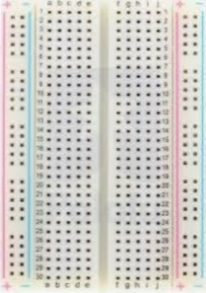

Led

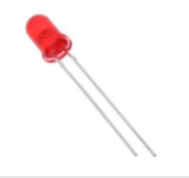

Function generator.

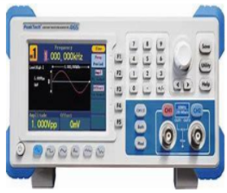

Resistors.

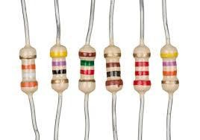

Power Supply.

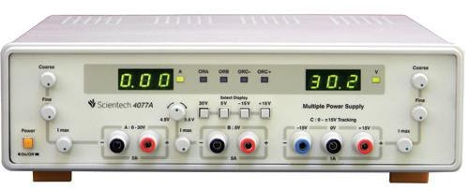

Digital Multi-meter.

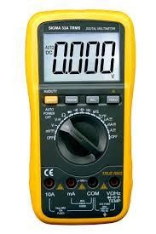

wires.

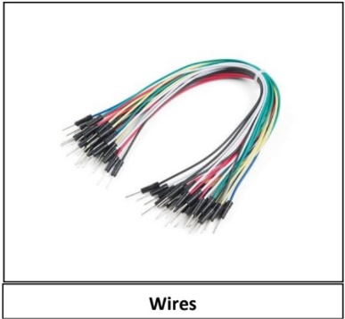

7404 Inverter

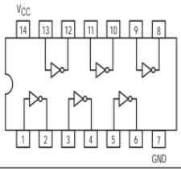

7432 OR-Logic Gate

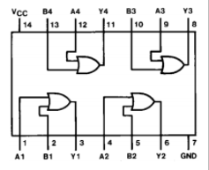

7408 AND-Logic gate

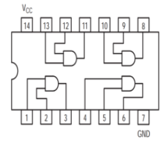

D flip-flop (7474)

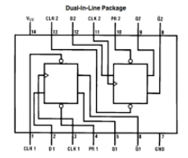

**Introduction:**

**procedure :**

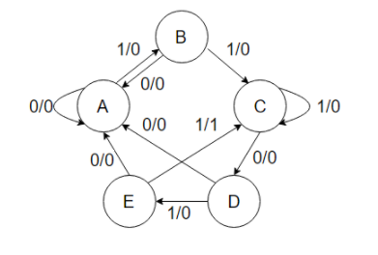

We have 5 state diagram so we want ceil(log25)= 3 D flip-flop, we will convert this state diagram to state table:

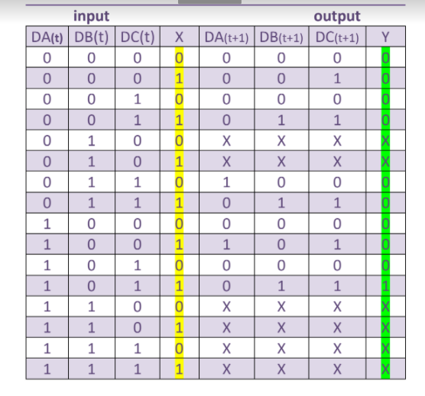

We will make a simplify by using k-map to find simple Boolean equation.

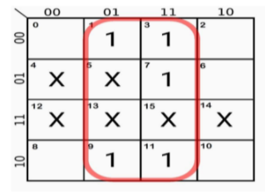

Dc=X

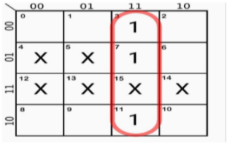

Db=DcX

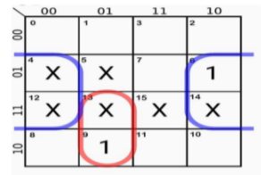

Da=Da(Dc)’X+DbX’

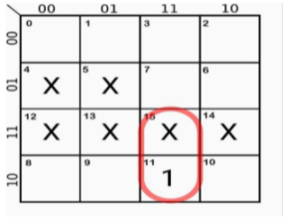

Y=DaXDc

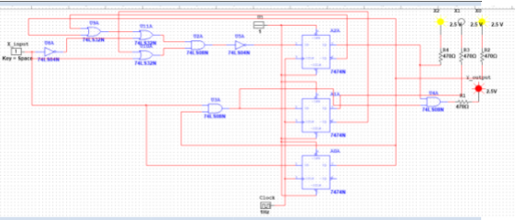

**Discussion:**

**Conclusions:**